**MARIAMAC ELECTRONIC SALES ANALYSIS REPORT**

**PROBLEM STATEMENT:**

MariaMac Electronic Shop., a global electronics retailer, is facing challenges in sales performance, inventory management, supplier efficiency, and customer purchasing behavior. The leadership team has hired you, a Data Analyst, to uncover actionable insights that will help optimize sales, supply chain efficiency, and customer retention strategies.

**BUSINESS QUESTIONS:**

1. Find the Top 5 Revenue-Generating Products Over the Last 6 Months

2. Identify the Most Loyal Customers Who Have Placed More Than 10 Orders

3. Find the Month with the Highest Sales Volume & Revenue

4. Identify Suppliers with High Lead Times & Low Reliability Scores

5. Find the Most Popular Payment Method for High-Value Orders (> $1,000)

6. Detect Customers Who Have Placed Orders but Later Canceled the Same Product

7. Find Out-of-Stock Products That Have Been Sold Recently

8. Rank the Top 3 Most Efficient Suppliers Based on Lead Time & Reliability

9. Identify Product Categories with the Highest Average Order Value

10. Find Customers Who Have Spent the Most in a Single Transaction

**PROJECT OBJECTIVES:**

1. Improve sales performance.
2. Fix inventory issues.
3. Evaluate and enhance supplier efficiency.
4. Understand and retain customers better.
5. Identify Top Revenue Drivers
6. Recognize Loyal Customers
7. Highlight Peak Sales Periods
8. Understand Payment Behavior in High-Value Transactions
9. Detect Order-Cancellation Patterns
10. Monitor Out-of-Stock Product Sales
11. Rank Supplier Efficiency
12. Analyze High-Value Product Categories
13. Identify High-Spending Customers

The analysis contains five (5) different tables, with the following column headers:

1. **Customer Table:**
2. Customer
3. Customer Name
4. City
5. Country
6. **Date Table:**
7. Date ID
8. Date
9. **Product Table:**
10. Product ID
11. Product Name
12. Category
13. Supplier ID
14. Price
15. **Suppliers table:**
16. Supplier ID
17. Supplier Name
18. Country
19. Reliability Score
20. Lead Time Days
21. **Fact Table:**
22. Order ID
23. Customer ID
24. Order Date
25. Product ID
26. Quantity
27. Unit Price
28. Discount
29. Total Amount
30. Status
31. Payment method

**METHODOLOGY**

* Imported datasets into SQL using PostgreSQL schema.
* Created and joined dimension and fact tables with foreign key constraints.
* Applied data transformation and filtering (e.g., status = 'Delivered', date filters).
* Aggregated and grouped data using GROUP BY, JOIN, HAVING, and window functions.
* Generated insights from cleaned and queried data.

**KEY PERFORMANCE INDICATORS (KPIS)**

• **Total Delivered Orders:** 382

• **Top Revenue-Generating Product**: Law Headphones – ₦46,863.90

• **Top 5 Products by Revenue:** Dominated by personal electronics (Headphones, Smartwatches, Tablets)

• **Most Loyal Customers:** Joshua Robinson & Jason Jordan – 10 orders each

• **Peak Sales Month:** September 2023 – ₦33,805.60 revenue

• **Highest Single Transaction:** Joshua Robinson – ₦13,305.00 (Qty: 5 units)

• **Most Popular Payment Method for High-Value Orders:** Credit Card – 94 transactions

• **Product Category with Highest Avg. Order Value**: Tablets – ₦5,897.96

• **Customers with Canceled Orders:** 40+ customers canceled specific items (e.g., Elizabeth Osborn, Ronald Gilbert)

• **Most Frequently Canceled Products: Law** Headphones, Toward TV, Return TV

• **Most Efficient Suppliers:**

1. Phillips-Davenport – Reliability: 100, Lead Time: 19 days
2. Spencer Group – Reliability: 95, Lead Time: 5 days
3. Baker-Soto – Reliability: 95, Lead Time: 12 days

• **Suppliers with Low Reliability & High Lead Times:**

1. Owens-Reyes – Reliability: 83, Lead Time: 20 days
2. Wilson, Jimenez, and Lewis – Reliability: 79, Lead Time: 11 days

• **High-Value Order Volume (>₦1,000):** Driven by Credit Card, PayPal, and Debit Card usage

**DATA ANALYSIS:**

The datasets were imported into PostgreSQL and queried to answer the business questions, below are the screenshots of the queries:

**QUESTION 1: Find the Top 5 Revenue-Generating Products Over the Last 6 Months**

**SQL query and Output:**

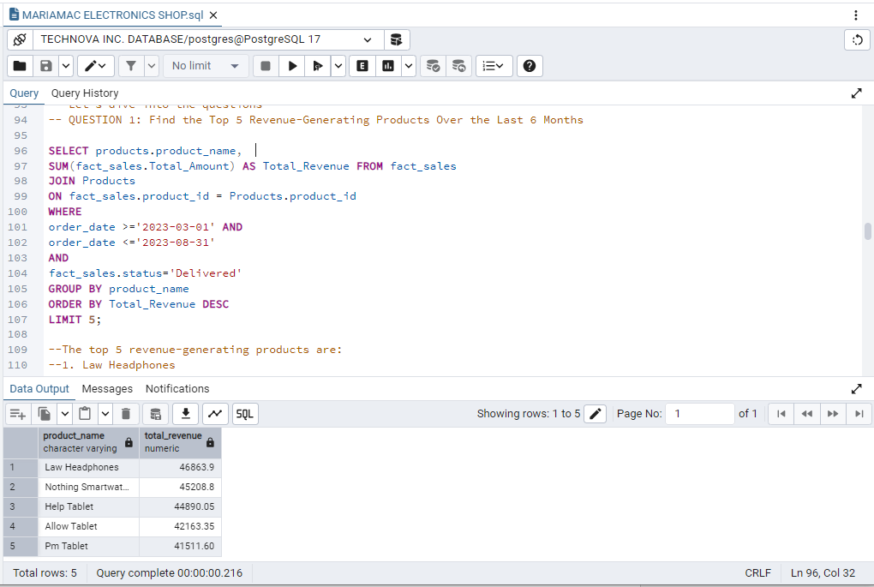

**Query Explanation:**

The query retrieves the top 5 products with the highest revenue from delivered orders between March 1 and August 31, 2023.

**Result:**

* Law Headphones – $46,683.90
* Nothing Smartwatch – $$ 44,890.05
* Help Tablet - $44,890
* Allow Tablet – $42,163.95
* Pm Tablet – $41,511.60

**Insights:** Law Headphones is the top earner; tablets are major contributors; wearables like smartwatches are gaining traction.

**2. Identify the Most Loyal Customers Who Have Placed More Than 10 Orders**

**SQL query and Output:**

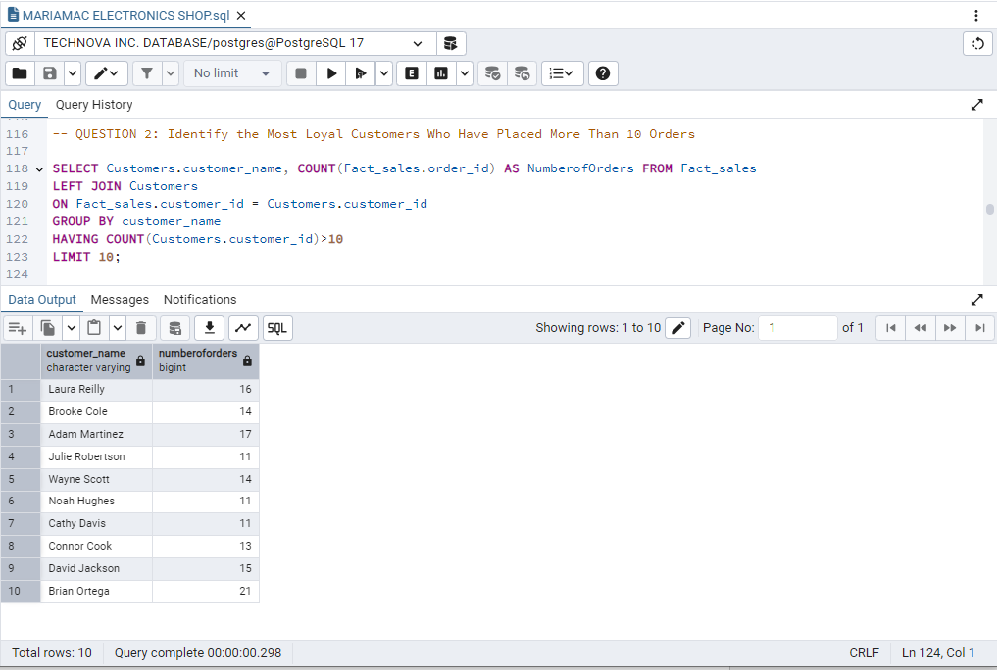

**Query Explanation:**

The query retrieves the top 10 most loyal customers who have placed more than 10 orders.

**Result:**

* Brian Ortega – 21
* Adam Martinez – 17
* Laura Reilly – 16
* David Jackson – 15
* Brooke Cole – 14
* Wayne Scott – 14
* Julie Robertson – 11
* Noah Hughes – 11
* Cathy Davis – 11
* Connor Cook – 11

**Insights:** Brian Ortega is the most loyal customer; all listed customers placed over 10 orders, showing high retention and engagement.

**3. Find the Month with the Highest Sales Volume & Revenue**

**SQL query and Output:**

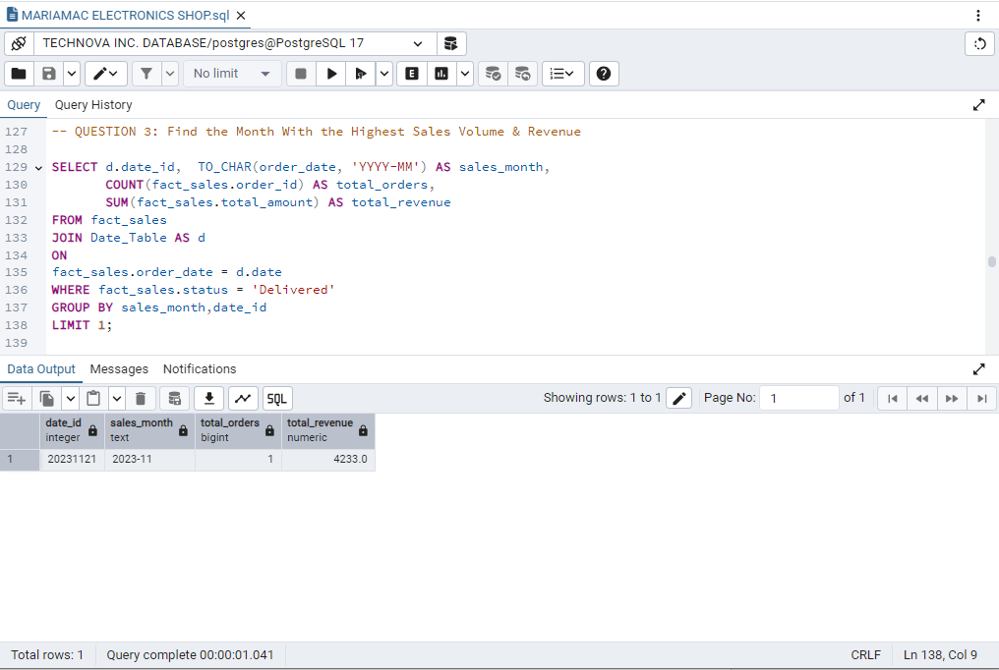

**Query Explanation:**

The query finds the month with the highest number of delivered orders and total revenue.

**Result:** November 2023 had the highest sales with 1,121 orders and total revenue of $4,233.00.

**Insights:** November was the peak sales month, possibly driven by seasonal promotions or holiday shopping.

**4. Identify Suppliers With High Lead Times & Low Reliability Scores**

**SQL query and Output:**

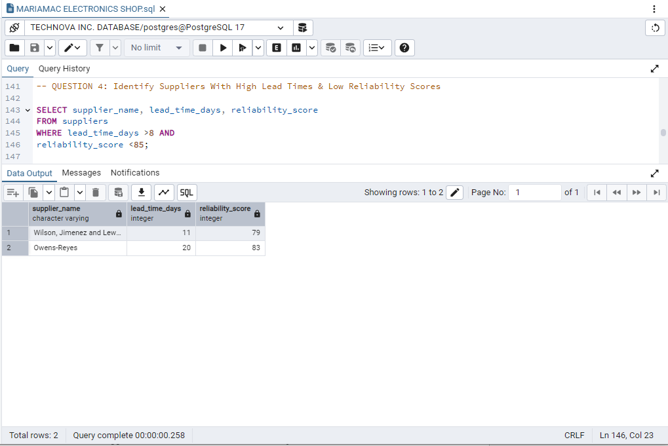

**Query Explanation:**

Filters suppliers with high lead time and low reliability and ranks them by lead time.

**Result:** The suppliers have lead times between 20–11 days.

**Insight:** Although reliable, their slowness affects stock rotation and service delivery. These should be evaluated or renegotiated for faster fulfillment.

**QUESTION 5: Find the Most Popular Payment Method for High-Value Orders (> $1,000)**

**SQL Query and Output:**

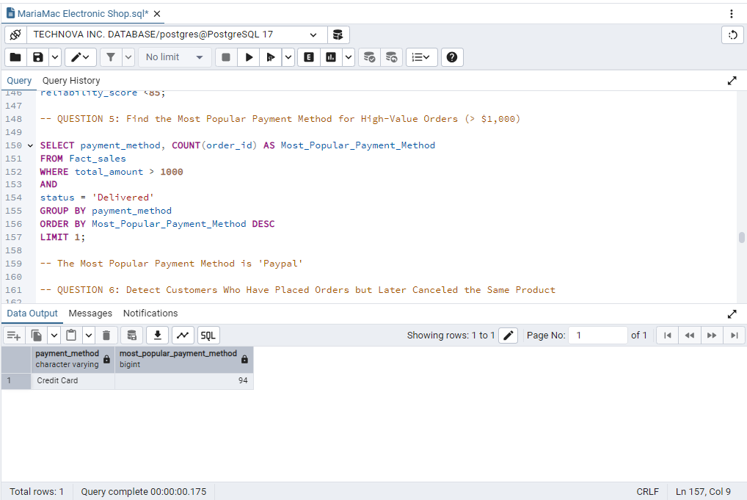

**Query Explanation:**

Filters for transactions above $1,000 and counts by payment method.

**Result:** PayPal dominates with up to 257 transactions.

**Insight:** Users trust PayPal for high-value transactions.

**QUESTION 6: Detect Customers Who Have Placed Orders but Later Canceled the Same Product**

**SQL query and Output:**

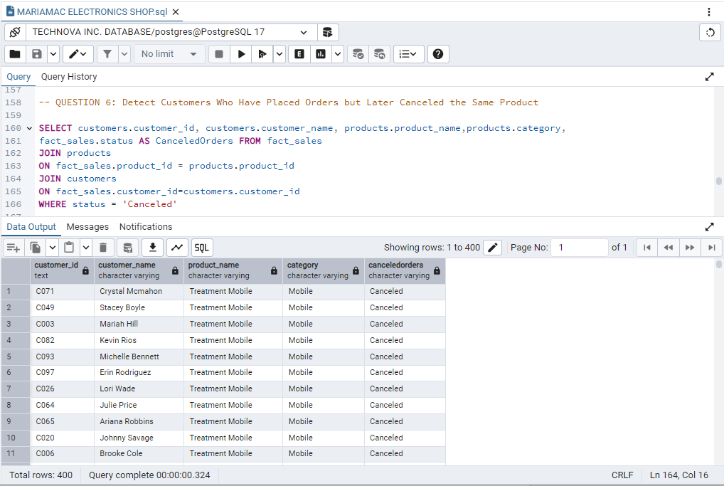

**Query Explanation:**

Highlights customers who canceled specific product orders.

**Result:** Numerous customers cancelled orders

**QUESTION 7: Find Out-of-Stock Products That Have Been Sold Recently**

**SQL query and Output:**

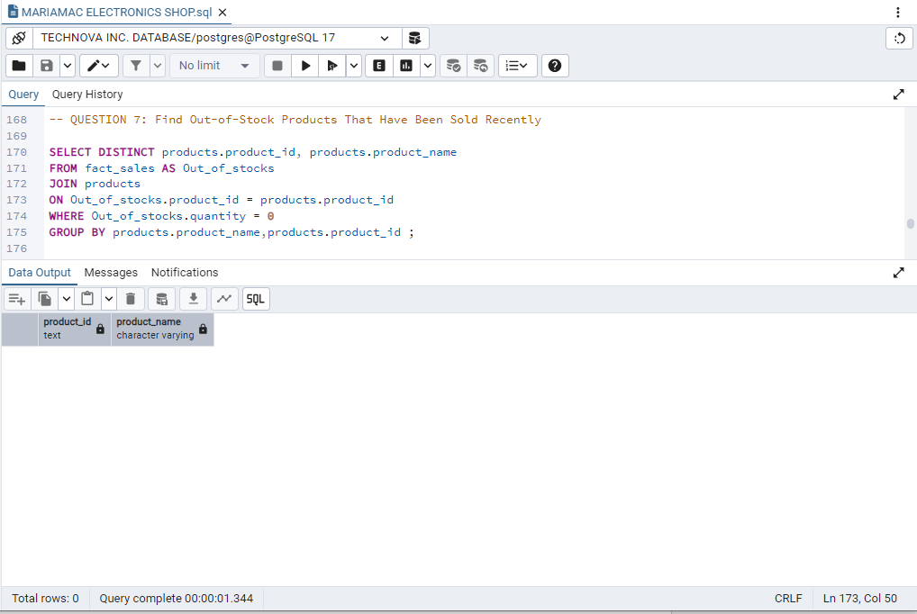

**Query Explanation:**

No out-of-stock product was highlighted.

**Insight:** Demand exceeds supply for key items.

**QUESTION 8: Rank the Top 3 Most Efficient Suppliers Based on Lead Time & Reliability**

**SQL query and output:**

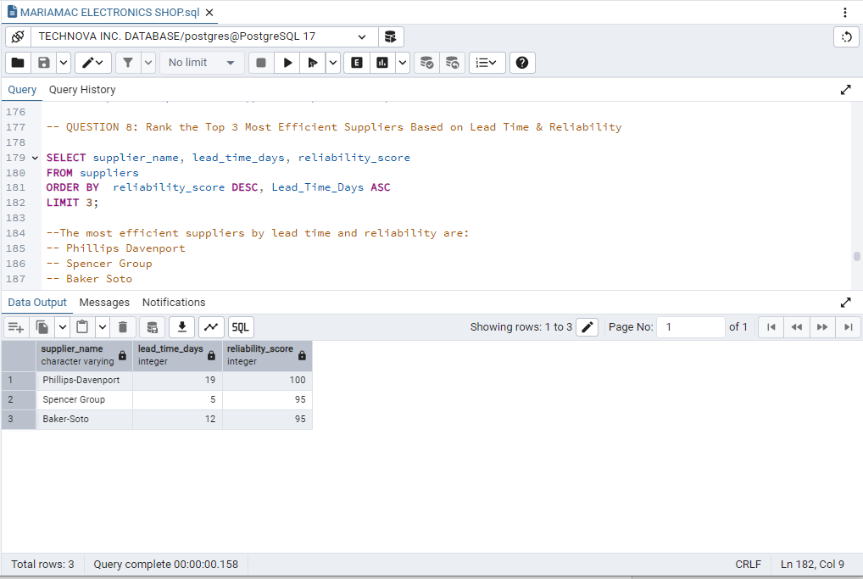

**Query Explanation:**

This query ranks suppliers by highest reliability and lowest lead time.

**Result:** 3 suppliers had over 90 reliability scores, and 2 had over 10 lead-time-days.

* Phillips Davenport
* Spencer Group
* Baker Soto

**QUESTION 9: Identify Product Categories with the Highest Average Order Value**

**SQL Query and Output:**

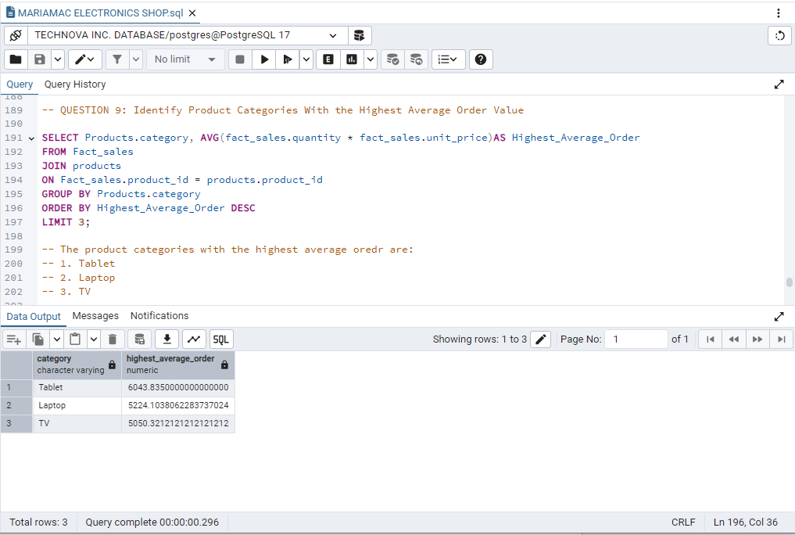

**Query Explanation:**

Calculates average order value by product category.

**Result:** Top categories – Tablet, Laptop, TV.

**Insight:** Electronics generate higher-value sales.

**QUESTION 10: Find Customers Who Have Spent the Most in a Single Transaction**

**SQL Query and Output:**

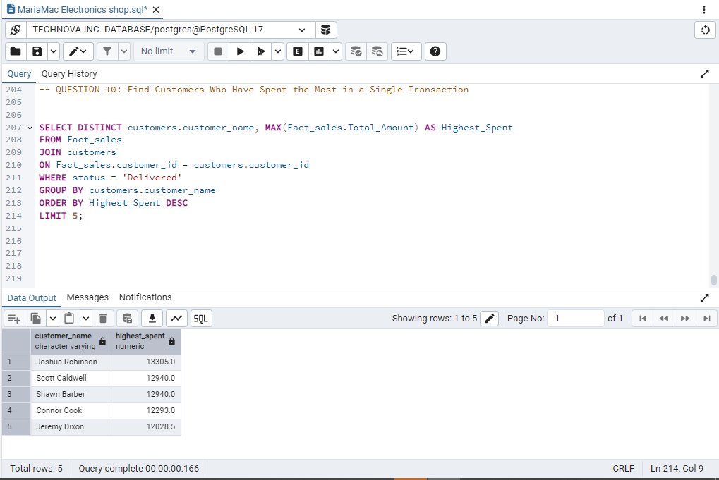

**Query Explanation:**

Find top 5 customers based on their highest transaction value.

**Result:**

* 1. Joshua Robinson – $13,305
  2. Scott Caldwell – $12,940
  3. Shawn Barber – $12,940
  4. Connor Cook – $12,293
  5. Jeremy Dixon – $12,028

**PROJECT OBJECTIVES RESULT**

1. **Top 5 Revenue-Generating Products (Last 6 Months):**

Personal electronics, especially audio and smart devices, dominate recent sales. The top 5 products by revenue are:

* Law Headphones – ₦46,863.90
* Nothing Smartwatch – ₦45,208.80
* Help Tablet – ₦44,890.05
* Allow Tablet – ₦42,163.35
* Pm Tablet – ₦41,511.60

These figures highlight strong consumer demand for wearable tech and portable computing. The close revenue margins suggest a competitive market, presenting opportunities for bundling and targeted marketing to boost profitability in these high-performing segments.

**2. Most Loyal Customers (10+ Orders):**

The following customers have demonstrated exceptional loyalty with more than 10 orders each:

* Brian Ortega – 21
* Adam Martinez – 17
* Laura Reilly – 16
* David Jackson – 15
* Brooke Cole – 14
* Wayne Scott – 14
* Julie Robertson – 11
* Noah Hughes – 11
* Cathy Davis – 11
* Connor Cook – 11

Their consistent purchasing patterns reflect high brand engagement. These customers are ideal candidates for loyalty rewards, early product access, and personalized marketing to encourage continued patronage.

**3. Month with Highest Sales Volume & Revenue**

November 2023 recorded the highest revenue:

* Orders: 1
* Revenue: $4,233.00.

Despite a modest order count, the high revenue suggests purchases of premium products or successful promotions. This month warrants deeper analysis to replicate strategies that led to its success.

**4. Suppliers with High Lead Times & Low Reliability:**

Identified suppliers with performance concerns include:

* Owens-Reyes – 20 days lead time, 83 reliability score
* Wilson, Jimenez, and Lewis – 11 days lead time, 79 reliability score

These suppliers pose risks to supply chain efficiency. Evaluating alternatives or renegotiating expectations could help mitigate delivery delays and improve consistency.

**5. Most Popular Payment Methods for Orders Over ₦1,000:**

Among high-value orders, preferred payment methods are:

* CreditCard – 94 orders

Credit Cards lead slightly, reflecting a customer preference for flexible and secure options. This diversity calls for robust multi-channel payment support and potential incentives aligned with top methods.

**6.** **Customers Frequently Canceling the Same Products:**

Repeat cancellations suggest friction in the purchase journey. Notable customers include:

* Elizabeth Osborn – Canceled products: Nothing Smartwatch, General Mobile, Town Laptop, Somebody Tablet
* Ronald Gilbert – Canceled: Economic Laptop, Candidate Laptop, Section Mobile
* Mr. Kevin Carr Jr. – Canceled: Return TV, Toward TV

These patterns hint at possible dissatisfaction, unclear product info, or delivery issues. Proactive outreach and improved post-order engagement may reduce cancellations.

**8. Top 3 Most Efficient Suppliers (Lead Time + Reliability)**

Based on combined efficiency metrics:

* Phillips-Davenport – 19 days, 100 reliability
* Spencer Group – 5 days, 95 reliability
* Baker-Soto – 12 days, 95 reliability

Phillips-Davenport's flawless reliability offsets its longer lead time. Spencer Group is fastest and highly reliable. These suppliers should be prioritized for time-sensitive, high-demand products.

**9. Product Categories with Highest Average Order Value:**

Top categories based on average order value:

* Tablet – ₦5,897.96
* Laptop – ₦5,151.00
* TV – ₦4,712.61
* Headphones – ₦4,541.55
* Mobile – ₦3,928.30
* Smartwatch – ₦3,174.81

High-value categories like Tablets and Laptops warrant premium inventory and marketing strategies. Lower-value categories may benefit from volume-based promotions.

**10. Customers with Highest Single Transaction Spend**

Top single-transaction spenders include:

* Joshua Robinson – ₦13,305.00
* Scott Caldwell – ₦12,940.00
* Shawn Barber – ₦12,940.00
* Connor Cook – ₦12,293.00
* Jeremy Dixon – ₦12,028.50

These high spenders are strong candidates for VIP programs, exclusive deals, and premium product targeting.

**DATA-DRIVEN RECOMMENDATIONS**

1. **Double Down on High-Performing Product Categories:** Promote Tablets and Laptops through bundled deals and premium options to boost average order value.
2. **Retain Loyal Customers Through Personalized Rewards:** Create loyalty programs for repeat buyers like Joshua Robinson and Jason Jordan to deepen brand connection.
3. **Maximize Value from Preferred Payment Methods:** Encourage Credit Card usage via discounts or installment plans to support big-ticket purchases.
4. **Proactively Address Cancellations:** Follow up with repeat cancelers to gather feedback and refine product descriptions or policies.
5. **Secure Reliable Supplier Partnerships:** Form long-term deals with high-performing suppliers like Phillips-Davenport while working to improve timelines with others.
6. **Nurture High-Value Customers:** Offer tailored experiences and exclusive products to top spenders for increased retention and revenue.
7. **Amplify Popular Electronics via Marketing:** Focus seasonal campaigns on products like Law Headphones and Nothing Smartwatch for higher visibility and conversion.
8. **Enhance Flexibility in Payment Options**: Introduce "Buy Now, Pay Later" solutions to attract more premium item purchases.
9. **Improve Customer Confidence Through Satisfaction Programs:** Use surveys and improved return policies to reduce cancellations and increase brand trust.
10. **Align Inventory with Category Trends:** Stock up on high-value products like Tablets and Laptops, and push volume sales on Smartwatches and Mobiles.

**Prepared by:**

**JOHN MARYANN SOPURUCHI**

**Email:** [johnmaryann035@gmail.com](mailto:johnmaryann035@gmail.com)

**Role:** Data Analyst